**Brooklyn torah gazette**

**For parshas vayakhel-pekudei 5780**

Volume 4, Issue 28 (Whole Number 180) 25 Adar 5780/ March 21, 2020

**Printed L’illuy nishmas Nechama bas R’ Noach, a”h**

**The Diabetic’s Dilemma: A Rabbi & Nutritionist Weigh In**

**By Rabbi Mordechai Merzel & Shoshana Merzel**

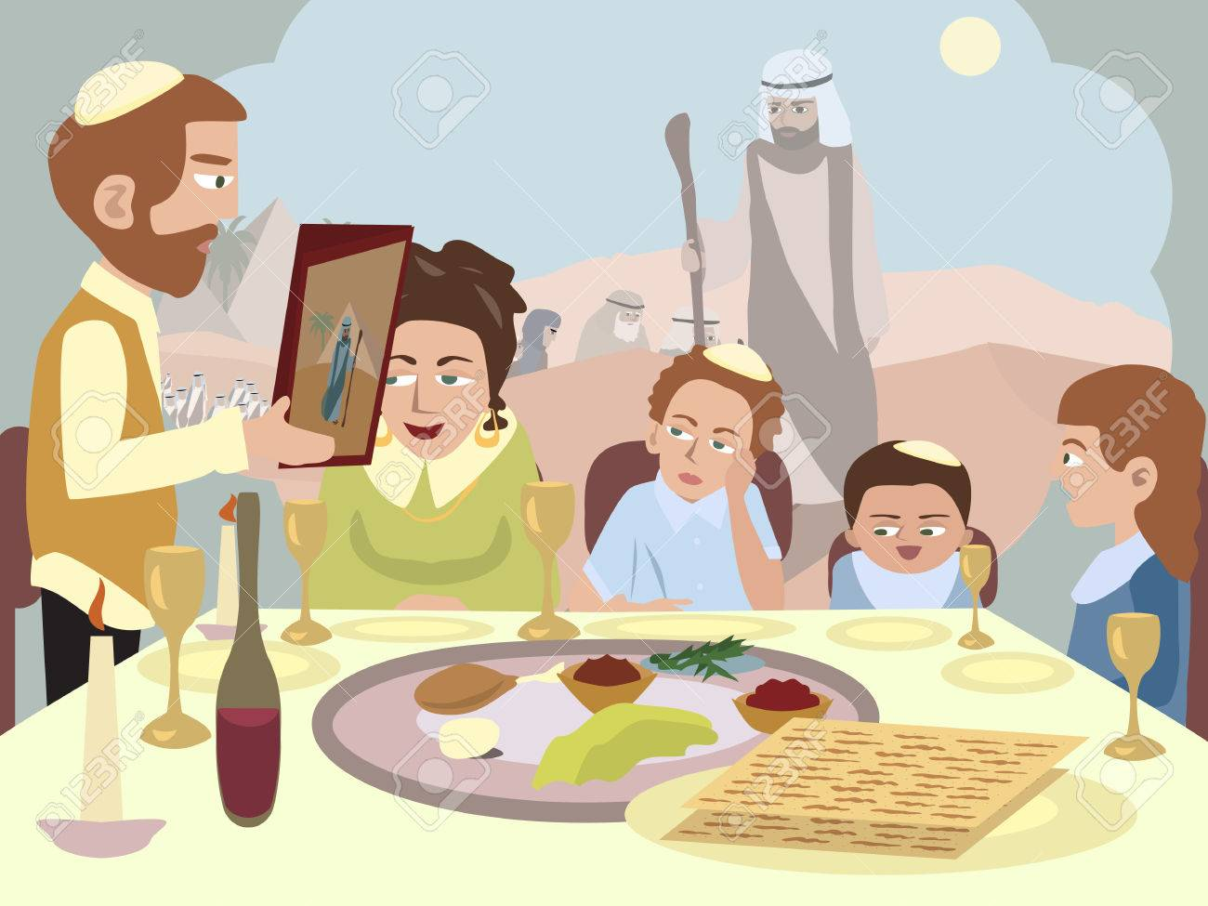

*Over 29 million Americans live with Type 2 diabetes. Diabetes requires significant adjustments to one’s lifestyle, involving careful monitoring of one’s food intake and blood sugar level. Pesach’s carbohydrate-laden rituals and festive meals bring additional challenges to an already challenging situation. Nonetheless, it can be done.*

**The Four Cups**

Although one can find dry wines with low sugar content, the alcohol in wine can induce hypoglycemia (low blood sugar), which can be very dangerous. Consequently, diabetics who take insulin may have to adjust their doses. Alcohol could also interact negatively with certain medications. Grape juice, due to its high sugar content (37g carbohydrate per cup), doesn’t offer a viable option.

Fortunately, both wine and grape juice may be diluted with water, minimizing the drawbacks for both. Alternatively, so long as the minimum amount is drunk, one need not drink the entire cup. Because it is *halachically* preferable to drink the entire cup and not to dilute the wine or grape juice, many will drink the four cups on the Seder night (with their doctor’s approval). If one plans to do so, consuming a high-fiber, high-protein snack just before *yom tov* could offset a hypoglycemic event. It is also advisable to use a cup that would hold the minimum *shiur* of wine.

Consult with your doctor to determine which option is the best for you, as well as with your rabbi to ascertain how much water to add to your cups (if this is the advised alternative), and the minimum*shiur* required for a diabetic to drink.

**The Matzot**

Matza is a high-carbohydrate food. Diabetics who are trying to control carbohydrate intake may be best off with machine *shmurah* matza, which lists the carbohydrate content on the box. Here again, diabetics should be aware of the minimum shiurim needed for *motzi matza*, *korech*, and *afikomen*, respectively, and keep any extra matza eating to a minimum. Since fiber can improve blood glucose control and help one feel fuller, whole wheat matza is preferable.

Some diabetics who take insulin must administer their dose within a specific time before eating.  However, the timing of *motzi matza* and *shulchan orech* can be difficult to predict. Make sure to consult with your doctor about how to best adjust your medication before the Seder to adapt to the change in schedule and menu.

Snacking

For diabetics, every morsel of food must be carefully measured; snacking and unconscious eating can wreak havoc with glucose control. Make sure that you leave each meal fully satisfied. Eating high fiber foods slows digestion and makes us feel full. *Yom tov* meals should contain an appealing choice of non-starchy vegetables. Good in-between meal snacks include a fruit with some protein, such as low-fat dairy, nuts, or an egg.

With the proper planning and preparation, one can successfully manage his/her diabetes and enjoy every celebrative aspect of the festival.

*Rabbi Mordechai Merzel, Marketing Department Director, OU Kosher   |  Shoshana Merzel, Certified Clinical Dietician*

*Reprinted from the OU Guide to Passover 5780.*

**Rav Avigdor Miller On**

**Plunging into Marriage**



**QUESTION:** What advice should I give to a boy who is of age to get married but doesn’t feel ready for it?

**ANSWER:** You have to tell him that he’s never going to feel ready for it, so he might as well plunge in. It’s like a man has to go to the *mikveh* on *erev Yom Kippur* and its freezing cold. Some *mikvehs* are hot, but let’s say in the country, the *mikveh* is cold and he’s standing on the brink contemplating what to do. So give him a little friendly push on the back. Once he’s inside, he’ll enjoy it. And marriage too; it doesn’t pay to contemplate – you just have to dive in.

Once there was a *rosh yeshiv*a who said marriage is like a pill in a capsule; a tasteless capsule. But inside, it’s a very bitter medicine. So if you swallow the capsule, it will be good; but if you start opening up the capsule and tasting what’s inside, you’ll spit it out and never swallow.

And so, don’t examine it too closely. Don’t examine the institution of marriage too closely and don’t examine the *kallah* too closely. If she comes from a *frum* family and she’s a *frum* girl, and she’s healthy, and she means business – she wants to have a lot of children, and she wants to be a housewife, not a career girl, and she wants to be *frum* and she shares your ideals, so dive in and Hakodosh Boruch Hu will help you. Once you start examining too much, if her nose is the right length, then you'll never find anyone who will suit you.

*Reprinted from the December 31, 2019 of Toras Avigdor adapted from Tape #427.*

**The Shmuz onParshas Vayakhel**

**Laziness or Lack**

**Of Motivation?**

**By Rabbi Bentzion Shafier**

**Founder of TheSmuz.com**



**Rabbi Bentzion Shafier**

*“The princes brought the shoham stones and the filling stones for the Eiphod and for the Choshen.”* — *Shemo*s 35:27

The *Nesi’im* (heads of the tribes) personally donated the precious stones for the breastplate of the *Kohen Gadol*. Even though this was an enormously valuable contribution, their name is written with a letter missing to denote something lacking in what they did.

Rashi explains that in the initial collection of materials for the Mishkan, the *Nesi’im* didn’t act properly. When Moshe called for donations, the *Nesi’im* said, “Let the congregation donate as much as it will, and we will fill in the rest.” They underestimated the generosity of the people, so in a short while, more than enough materials were collected to build the Mishkan and its vessels. And the *Nesi’im* found themselves without anything left to dedicate.

They immediately took it upon themselves to donate the full amount needed for the precious stones. So even though this act was very generous, their name is written in a shortened form because of their original laziness.

Everything in this Rashi seems to make sense except for the word, “laziness.” Rashi seems to be saying that initially the *Nesi’im* were lazy, and because of that, they lost their chance to be part of the building of the Mishkan. Where do we see *laziness* in their actions? At first, they made a gallant statement: “Let the people give, and whatever is lacking, we will make up for.” They were wealthy men who took full responsibility for the construction. “Whatever is missing, we’ll give.” What they did seems noble. Why are they accused of laziness?

The answer to this Rashi can best be understood by focusing on a *mashal*.

**The World’s Most Beautiful Diamond**

One of the most magnificent diamonds ever shown is the Millennium Star. It is pear shaped, D color, internally and externally flawless, and weighs in excess of 200 carats. It is insured for approximately 200 million dollars, but by most estimates, that’s only a fraction of its actual value. If you know diamonds, just seeing it takes your breath away.

But that’s not how the diamond started out. It was found in a diamond mine in South Africa, and when it first came out of the ground, it was 777 carats — a rough, dirty clump. It was clear that within it was a diamond of extraordinary value, but it was a challenge to cut away the rough in a manner that would leave the largest section of unspoiled diamond.

The DeBeers company hired a team of diamond cutters headed by Nir Livnat, an Israeli-born diamond cutter. Using high-powered microscopes, the team created countless diagrams and more than one hundred computer-generated models of the stone to determine the correct cut. They labored at it for three years. The actual cutting was to be done by laser, under laboratory conditions similar to a sterile operating theater. The temperature and humidity were carefully controlled, and special tongs were designed to hold the rough.

Finally, they felt ready, and the procedure was scheduled. On the day of the event, the team gathered, and everyone held their breath. In just a moment, they would either be looking at the world’s most precious gem or a worthless clump of stone.

Nir gave the command, and the process began. Out came a near-perfect, magnificent 200-carat diamond. And as the story is told, the gravity of the moment fully hit him, and Nir passed out.

**Eternal Value**

This seems to be the answer to Rashi. The *Nesi’im* had a rationale for what they did, yet, if they would have had a greater appreciation of the opportunity presented to them, they wouldn’t have acted that way.

The *Nesi’im* were offered a chance to be a part of history. They could have had a part in the building of the Mishkan, HASHEM’s dwelling place on this earth! Because they didn’t fully appreciate what that meant, they said, “Whatever the congregationdoesn’t give, we will give.” Their words implied, “Let others do it; we’ll sit back.” While they may not have intended to be lazy, that was a lackadaisical attitude, and it manifested as laziness in action.

**Two Causes of Lazy Behavior**

This is eye-opening, as it teaches us a fundamental concept.

All growth requires change, and change requires energy. I have to move out of the way I have been doing things and learn a new way. Clearly, laziness is the enemy of growth.

The *Mesillas Yesharim* (Chapter 6) explains that man by nature is lazy. HASHEM created us out of earth, and the nature of earthiness is to be heavy. Man by his very design is heavy and sluggish. To combat this, a person must learn to move with alacrity, to begin right away and to carry through until the end.

In addition, there is a second element that will determine a person’s actions: his value system. Even a lazy man will push himself if the stakes are high enough. If he knows he can make a hundred million dollars in a day, he’ll find a way to get himself moving.

The point is that there are two distinct elements that impact a person’s actions: inborn laziness and the value that he places on something. For a person to reach his potential, he must work on both fronts. He has to work on laziness directly, and he has to work on his value system as well. The more he recognizes the extraordinary value of even a single mitzvah*,* the more he will be motivated to charge forward and accomplish what he can in his short stay on this world.

*Reprinted from this week’s website on TheShmuz.com This is an excerpt from the [Shmuz on the Parsha book](https://theshmuz.com/product/shmuz-on-the-parsha-book/).*

**Our Faulty Understanding**

**Of the Shape of the Menorah**

**From the Talks of the Lubavitcher Rebbe**

**Rabbi Menachem Mendel Schneerson, Zt”l**

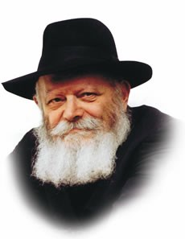

“And he made the candlestick of pure gold," we read in this week's Torah portion, Vayakhel. "And six branches were coming out of its sides: three branches of the candlestick out of its one side, and three branches of the candlestick out of the other side."

Surprisingly, a widespread misconception exists concerning the menora that stood in the Holy Temple.

This misconception, whose origin lies in non-Jewish sources, has unfortunately filtered down into Jewish circles, resulting in a faulty understanding of the genuine appearance of the menora.

In truth, the six side branches of the seven-branched candelabrum rose upward diagonally in a straight line from the center; they were not, as is commonly pictured, rounded in a bow-shape.

What makes this error even more regrettable is that it is derived from the famous Arch of Titus, may his name be blotted out forever.

The Roman emperor, seeking to memorialize his destruction of the Second Holy Temple and his pillage of the Temple's vessels, commissioned a work to secure his place in history. Its depiction of the menora, however, is not an accurate representation of the one that was stolen from the Beit HaMikdash. Titus wished to improve upon the original and therefore "beautified" it by rounding out its branches.

The Hebrew word for "branch" -- "kaneh" -- alludes to the menora's true shape, for its literal meaning is "a reed" -- a plant which grows at the water's edge in an unbending, straight line.

Both Maimonides and Rashi concur that the branches of the menora were straight; Maimonides even drew a picture of the menora so there would be no room for doubt.

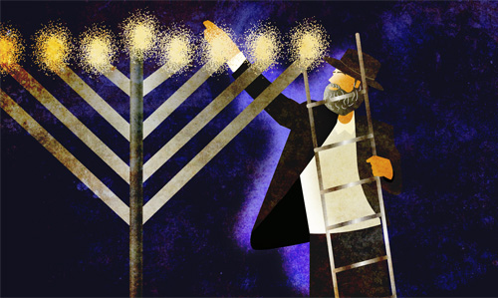

It is of the utmost importance that this ancient forgery, which, unfortunately, has found its way into many synagogues and study halls, be corrected once and for all, and the true form of the holy menora be accurately depicted.

Another interesting feature of the menora was its "cups": "Three cups, shaped like almond blossoms, were on one branch, with a knob and a flower; and three cups, shaped like almond blossoms, were on the other...on the candlestick itself were four cups, shaped like almond blossoms, with its knobs and flowers" -- a total of 22 cups in all.

In his drawings, Maimonides depicts these cups upside-down -- the bottom of the cup on top, the wider opening on the bottom!

What are we to learn from the cups' unusual configuration?

The purpose of the menora was to illuminate -- not only the inside of the Holy Temple, but the entire world.

This concept is also reflected in the fact that the windows of the Beit HaMikdash were constructed to be narrow on the inside yet wider on the outside of the structure, thereby channeling the light of the menora outward, to the world at large.

Similarly, a cup that is upside-down represents the act of pouring out and providing sustenance, symbolic of the Jews' role as "light unto the nations."

*Reprinted from the Issue #356 of L’Chaim Weekly (Parashat Ki Tisa 5755/1994)*

**Rabbi Berel Wein**

**On Parashas Vayakhel-Pekudei**

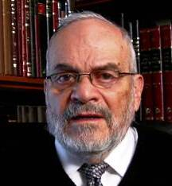

Moshe gathers all of the people of Israel into the courtyard of the Tabernacle to instruct them about the observance of the sanctity of Shabbat. That is the content of the lead verse of this week’s Torah reading. The obvious question raised by all of the Torah commentators is whether there was insufficient physical space outside the Tabernacle to hold the entire population of the Jewish people. Talmud and Midrash, therefore, resort to a miraculous supernatural understanding of the event.

They state that here we are taught the concept that the small and few can somehow contain and hold the large and many. We naturally consider this to be miraculous. But in the realm of the Almighty, where space and time do not really exist, there is no problem in having millions occupy a limited area of space. And since the Tabernacle, and later the Jerusalem Temples, were miraculous in their very nature and essence, even in their construction, it is obvious that such a supernatural phenomenon existed to gather all the Jewish people within a limited area.

The Talmud asserts that the Jewish people in that generation were accustomed to miracles and to the supernatural events. With regular exposure to the supernatural, it eventually makes it natural and easily accepted. The Torah also assumes that those that study Torah will never discount the presence of the supernatural in the Jewish narrative. In Jewish thought and experience, the dividing line between natural and supernatural is blurred. The Tabernacle is proof if this axiom.

The Talmud instructs us that this miracle of the limited containing unlimited also existed in the times of the Temple in Jerusalem. Pirke Avot teaches that the Jews in the Temple courtyard stood pressed against one another. However, during the Temple service, when the moment arrived for everyone to kneel and prostrate themselves before the Holy Presence, there was sufficient space for all to do so comfortably.

The great moral and practical lesson derived from this phenomenon is obvious and telling. When people insist on standing erect, in protecting their own perceived interests and turf, the world is very crowded and there is always hostility to neighbors and companions. However, if we are willing to bow down, certainly to G-d - but even towards the needs and dignity of other human beings, there will always be enough space and room for all.

The L-rd has so fashioned human society in a way that successful living – be it in the milieu of family or community or economic well-being -- is always dependent on accommodating others. The customer is always right is the key to successful commercial enterprise.

It is not within our nature to bow down easily. The Torah emphasizes, time and again, our individual responsibility to society as a whole. The tabernacle and Jerusalem Temples came to represent this basic concept of flexibility over rigidity and humility over selfish arrogance. Even though the Temple is not yet in our midst physically, its spiritual message certainly is with us.

*Reprinted from this week’s website of Rabbiwein.com*

**The Merit of the**

**Righteous Women**

**By Rabbi Eli J. Mansour**



We read in Parashat Vayakhel of Beneh Yisrael’s generous and enthusiastic response to Moshe’s call for donations of materials for the construction of the Mishkan.  The people came in droves, joyfully parting with their precious possessions for the sake of building a Sanctuary so that G-d would reside among them.  The Torah makes a point of emphasizing that both the men and women came, and the commentators note that the women’s generosity exceeded that of the men.  They came before the men with their gold and silver jewelry, ready and willing to donate for this sacred cause.

It has been suggested that the women’s generosity is especially significant in light of the events we read in last week’s Parasha, Parashat Ki-Tisa.  The people confronted Aharon and demanded that he make for them a leader to take the place of Moshe, who had not returned from the top of Mount Sinai.  In an attempt to stall for time, knowing that Moshe would soon return, Aharon decided to invite the people to donate their gold in order to fashion a golden calf.

He figured that the people would not be so quick to part with their wealth, and this request would thus buy him time.  In the end, Aharon was only partially correct.  The women refused to give away their gold jewelry, but the men were zealously committed to the project and happily donated their gold.  And thus the tragedy of the golden calf unfolded.

Why did the women refuse to give away their gold jewelry?  Was it because of a woman’s natural affinity for her jewelry?  Or was it due to idealism, to the women’s staunch opposition to the idea of worshipping a golden calf?

This question was answered in resounding fashion when the donations were brought for the construction of the Mishkan.  The women led the charge, flocking to the site to donate their jewelry.  At that point it became abundantly clear that the women were happy to part with their jewelry for a worthwhile cause, and that their refusal to give their jewelry for the golden calf was due to their rejection of idol worship, and their firm commitment to G-d.  Indeed, our tradition teaches that women were given an extra holiday in reward for not participating in the sin of the calf – Rosh Hodesh, when many women have the custom not to work.

This is not the only example of the women’s staunch devotion.  The Torah tells that the women spun the wool that was needed for the Mishkan, and the Sages explain that they spun the wool directly from the sheep, to ensure it would be as white as possible.  This was, no doubt, a very difficult and complicated process, but the women were insistent on doing everything at the very highest standard, and so they found a way to do it.

The Israelite women played a special role already in Egypt, during the period of slavery.  The men, who spent their days performing grueling labor, were broken, despondent and in despair, to the point where they did not want to beget children.  The women, however, remained upbeat and confident in the promise of redemption.  They worked to lift their husbands’ spirits and give them the encouragement they needed to continue maintaining marital life and begetting children.

And so the Sages teach that the Exodus occurred in the merit of the righteous women among Beneh Yisrael.  Without them, our nation’s story would have ended in Egypt, Heaven forbid, as the men had fallen into despair.  It was only because of the efforts and optimism of the righteous women that Am Yisrael was sustained even during those years of hardship and oppression.

This pattern continued during the tragedy of the spies, who returned from their excursion and dissuaded the people from proceeding into Eretz Yisrael.  Once again, the women remained steadfast in their faith as the men despaired.  The men heard the spies’ frightening report and wept, deciding they could not possibly take possession of the land.  The women, however, trusted in Hashem’s promise and were resolute in their belief that He would lead the nation to victory against the people of Canaan.

There is an all-too-common misconception that Orthodox Judaism is prejudiced against women, and views them as inferior and unimportant.  Nothing could be further from the truth.  It is true that our tradition assigns different religious responsibilities to men and women, but this in no way reflects its “preference” for one over the other.

To the contrary, Hazal credit the Israelite women with rescuing our nation, and portray them as the courageous heroines who remained strong and steadfast when the men proved to be weak.  While traditionally it has been men who have written the works of Torah that we study and cherish, it is the women that have sustained our nation’s spirit throughout the millennia just as they did in Egypt and at Sinai, through their unshakeable faith and devotion to G-d even during the most trying times.  It is in their merit that we left Egypt, and it is in their merit that we are still flourishing today after centuries of exile.

[1801 Ocean Parkway, Brooklyn, NY 11223](https://www.google.com/maps/dir/?api=1&destination=1801+Ocean+Pkwy+Brooklyn+NY+11223)

*Reprinted from this week’s website of The Edmond J. Safra Synagogue in Brooklyn.*

**Thoughts that Count**

*Six days a week shall work be done, but on the seventh day there shall be to you a holy day, a Sabbath of rest to G-d* (Exodus 35:2)

The Torah does not state "you shall do work," but rather, "work shall be done," to teach us that our labors must always be viewed as if they are accomplished by themselves, without our active participation.

A Jew must always strive to maintain this healthy attitude towards work to make it easier for him to mentally divest himself of his business worries on Shabbat.

Investing an inordinate amount of mental energy into one's business makes it harder for him to properly appreciate the spiritual dimension of the Shabbat day.

*(The Lubavitcher Rebbe)*

*Reprinted from the Issue #356 of L’Chaim Weekly (Parashat Ki Tisa 5755/1994)*

**A Fascinating Array of**

**Rare and Important**

**Judaica Collectibles**

**By Daniel Keren**

(Kedem –Auctions Catalogue #69 – Part 1, 2019, 280 pages, paperback, Jerusalem)

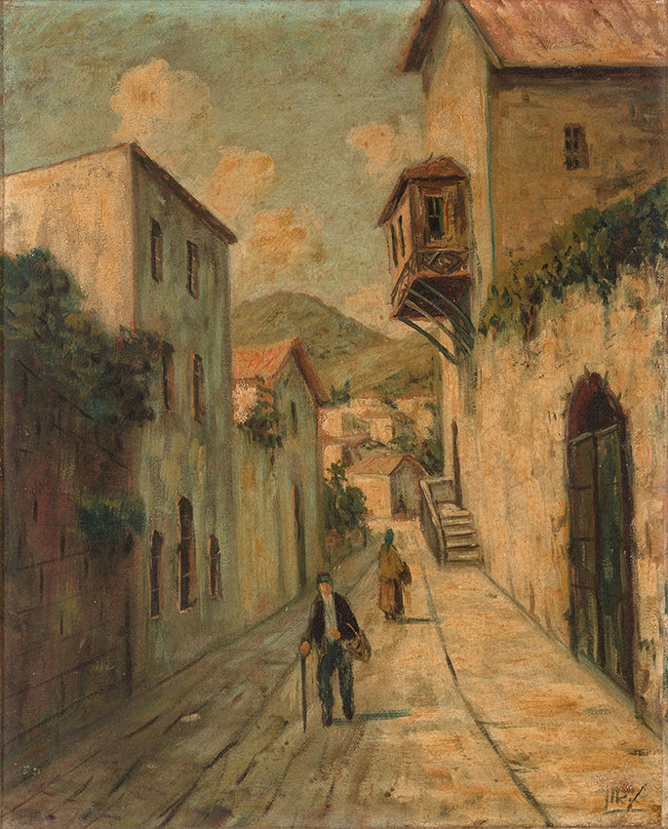

**Safed alleyway, with a mountainous landscape in the background. Painted by Rabbi Yehuda Leon Patilon**

In mid-February, I had the privilege to spend a week in the Promised Land – Eretz Yisroel visiting family and holy sites. One such visit was to my cousin and her son and it was there that we got into an interesting discussion on the topic of Judaica collectibles. My cousin’s son – Uriel Libson works for a Jerusalem based auction house named Kedem ([www.kedem-auctions.com](http://www.kedem-auctions.com)) and he showed me a copy of a recent auction catalogue (#69 – Part I) that highlighted rare and important Judaica items. The auction was conducted on December 3, 2019.

Uriel is one of seven editorial writers employed by Kedem Auctions located at 8 Ramban Street in Jerusalem. He explained to me that he researches and writes on some of the items selected for the auction lots. He writes in Hebrew and other editorial staff members translate his descriptions into English. Every lot is described in the catalogue in both Hebrew and English.

The Kedem Auction Catalogue #69 – Part 1 is now in my personal library thanks to Uriel. It is in my opinion a most fascinating literary work in and of itself, especially with the excellent lot descriptions written up by my cousin’s son and his colleagues.

It is certainly not a quick read like a chapter or two of one of Rabbi Berel Wein’s excellent history books. It is more like reading one or two lot descriptions at a time and most likely the type of catalogue book that one would skip over lots on Judaica collectibles that just don’t catch one’s fancy.

Kedem Catalogue #69 – Part 1 is divided into 17 different categories: Torah Scrolls and Esther Scrolls; Illustrated Manuscripts and Manuscripts of Prayers; Manuscripts; Chassidism – Manuscripts and Letters; Rabbinical Letters; Books with Glosses and Signatures and Books of Important Ownership; Chassidic Books; Chassidic Books – Chabad; Slavita and Zhitomir; Bibles and Prayer Books; Talmud and Mishnayot; Miscellaneous Books; Judaica Objects; Jewish Communities and European Monarchs; Holocaust and Sheerit Hapletah; Zionism, Palestine and Israel – Noted Jewish Personalities; and Graphic Art and Paintings.

I have decided to illustrate Lot #99 which shows an oil painting by the late Kabbalist or “The Holy Painter” – Rabbi Yehuda Leon Patilon The painting depicts a Safed alleyway, with a mountainous landscape in the background. R. Yehuda Leon Patilon (ca. 1905-Cheshvan 1974), painter and kabbalist, was renowned as a wonder-worker with foreknowledge of the future, well-versed in the domain of souls and reincarnations.

Born in Salonika, Greece, he was orphaned of his father at a young age, and was raised by his grandfather, a kabbalist, who bequeathed to him his kabbalistic approach in worship of G-d, which included rising at midnight and study of Kabbalah. Following his conscription in the Greek army, he fled to Turkey and France (where he presumably studied art).

In ca. 1946, he immigrated alone to Eretz Israel, where he drew close to a group of hidden Tzaddikim in the Shabazi neighborhood of Tel Aviv. These men, who earned a living from manual labor while secretly gathering to study Kabbalah together, included: R. Moshe Yaakov Rabikov ("the shoemaker"), the hidden Tzaddik R. Hillel Simchon, R. Avraham Fish ("the floorer"), and R. Ezra Eliyahu HaKohen (father of "the milkman", R. Chaim Kohen).

His teacher R. Hillel Simchon arranged his match with his wife – Rebbetzin Victoria from the Jerusalemite Nisan family, and they lived in great modesty in the Shabazi neighborhood of Tel Aviv, barely sustained by the sale of his paintings. R. Patilon would set the price of his paintings based only on the cost of the paper, the paint and the work time, although as a talented artist, he could have asked for a much higher price R. Yehuda Patilon would paint whilst engrossed in spiritual reflections, completely dissociated from the material world, yet his paintings remain realistic. The painting opened at $1,000 and was knocked down to the successful bidder at $2,600.

*Reprinted from the March 20, 2019 edition of the Jewish Connection.*

**More Thoughts that Count**

*You shall not kindle any fire throughout your dwellings on Shabbat* (Exodus 35:3)

Why does the Torah single out this prohibition from amongst the other 39 types of labor which are also forbidden on Shabbat?

Heated arguments and disputes are like a fire; unfortunately, controversy has the power to disrupt many a peaceful home. When people are occupied with their daily tasks they do not have time to argue with one another; on Shabbat, however, they are less busy than during the week.

The Torah therefore warns us not to kindle the fires of controversy on Shabbat by keeping ourselves busy with Torah study and prayer.

Incidentally, rearranging the final letters of the above verse in Hebrew results in the word "shalom" -- "peace"! *(Our Sages)*

*Reprinted from the Issue #356 of L’Chaim Weekly (Parashat Ki Tisa 5755/1994)*